Point 1:-
Looks some issue with trendline under Golden Tab
Give information like two more fields Monthly trendline and weekly trendline(apply vertical trendline to get the price of the touch and horizontal line to get value of price like show you in below example of obero reality ,pidilite ,beml,lupin)
(Trendline should be around 1390-1420 instead of 1633) Add 200EMA price as well
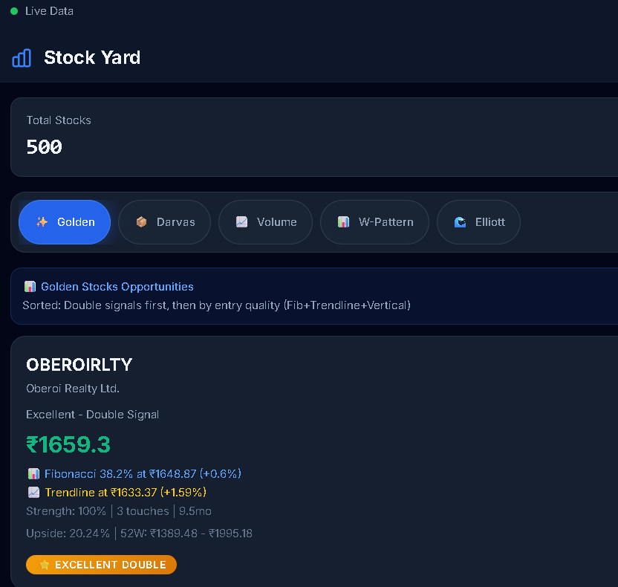
Trendline should be around 1390-1420 instead of 1633
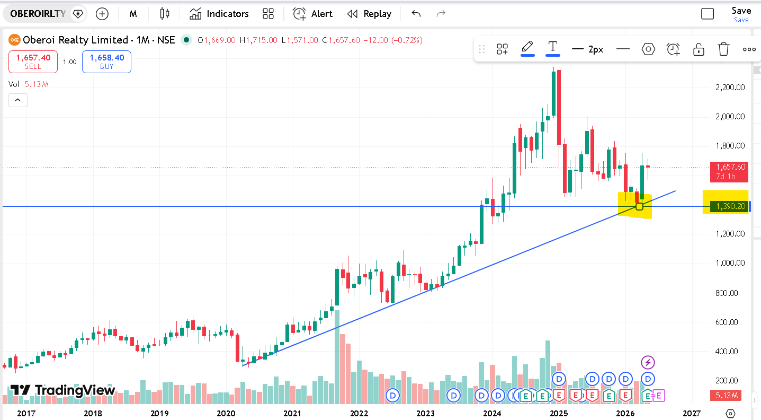
Trendline at 1283 see below instead you mentioned 1453
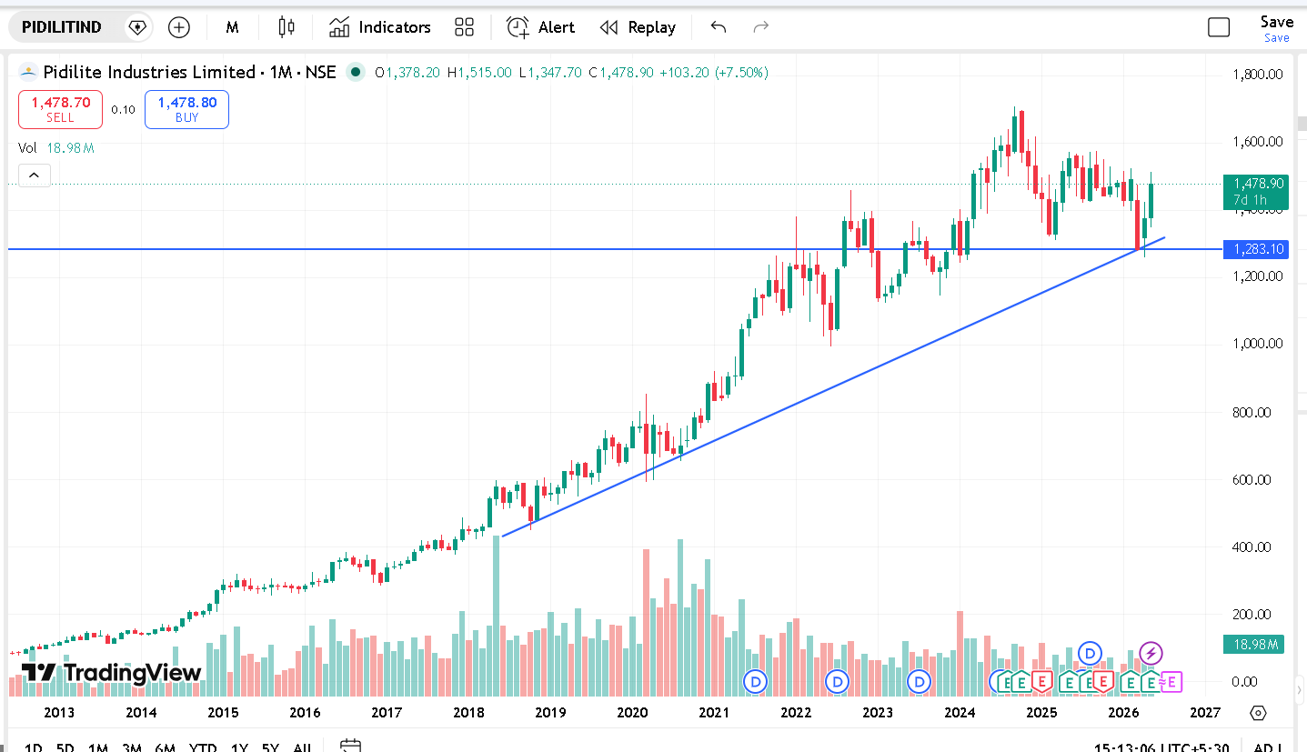
See same pattern with BEML ,trendline at 1350 (you should mentioned instead of leaving it blank)
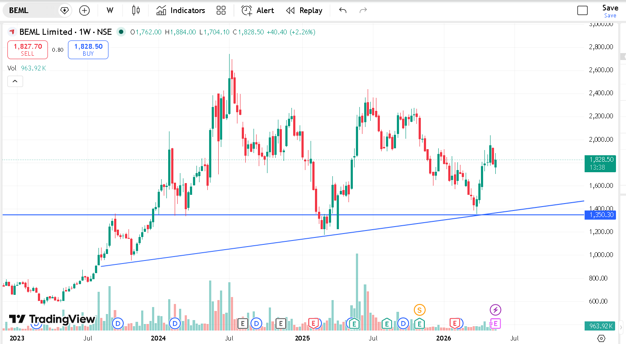
See trendline at 601
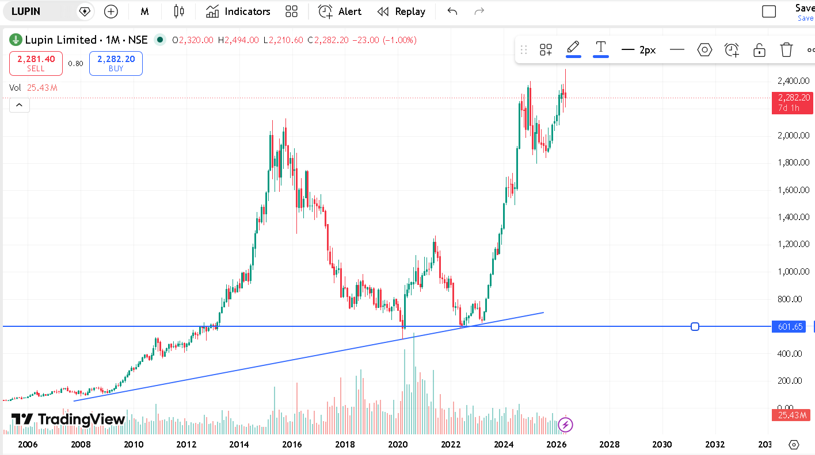

Point 2 :-
Why I don’t see trendline price in most of the stocks under Golden tab ?
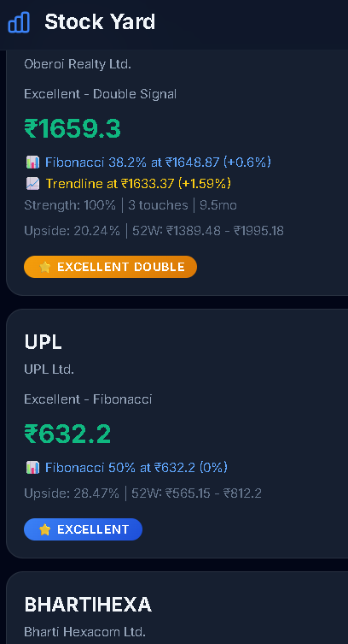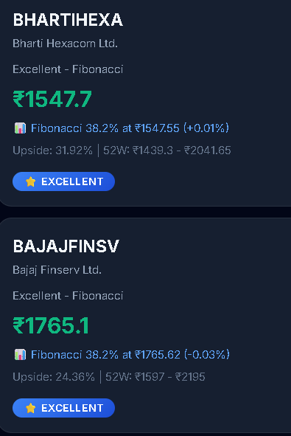

Point 3 :- Darvas box consolidation should be atleast 2 years thn 2-3 yrs ,2-4yrs, then2-5 years

